A guide to definitions for genetically modified food and novel DNA in the Australia New Zealand Food Standards Code
June 2026

Table of Contents
A. About this guidance 3
What this guidance does 3
What this guidance does not do 3
B. About compliance 3
Whose responsibility 3
This guidance is not a legal document 4
1 Introduction 5
2 Genetically modified food 6
2.1 Determining what is a GM food 7
2.2 Foods and substances that are excluded from the GM food definition 8
2.2.1 Food additives and Processing aids 8
2.2.2 Substances used to support or process cells in cell culture 9
2.2.3 Food derived from part of a grafted plant 9
2.2.4 Food derived from null segregants 12
3 3 Novel DNA 13
3.1 Determining what is novel DNA 13
3.1.1 Has a person inserted DNA into the genome of an organism, cell or cells? 15
3.1.2 What is the source and form of the inserted DNA? 15
3.1.3 DNA that is not from an existing species 15
3.1.4 Crossable and non-crossable species 16
3.1.5 Rearranging or recombining the coding region of DNA from a crossable species prior to insertion 19
3.2 What is not novel DNA 22
3.2.1 Left and right border sequences from Agrobacterium 22
3.2.2 Endogenous genome changes (natural or induced) 22
3.2.3 Short sequences that are attributable to all species 22
3.2.4 Natural insertions 23
3.2.5 Codon optimisation 23
3.2.6 Deletions 23
4 Additional information 24
4.1 Is my food a novel food? 24
4.2 Changing the Code 24
4.3 Cultivating or importing GM organisms 24
5 References 26

- About this guidance

What this guidance does
- Explains how the definitions of genetically modified food and novel DNA in the Australia New Zealand Food Standard Code (the Code) may apply.
- Supports consistent interpretation of those definitions by food developers and regulatory agencies.

What this guidance does not do
- Provide information on pre-market safety assessment requirements for genetically modified (GM) foods.
- Provide guidance on GM labelling.
- Provide detailed information on regulatory pathways for foods that do not meet the genetically modified food definition but are regulated under other parts of the Code e.g. processing aids, food additives, or novel foods.
- About compliance

Whose responsibility
Responsibility for determining whether a food meets the genetically modified food definition rests with the food developer or business. Developers are expected to maintain appropriate records to support this determination, and to provide this information if requested by a food regulatory agency.
In Australia, state and territory food regulatory agencies along with local councils are responsible for enforcing the Code. The Australian Government Department of Agriculture, Fisheries and Forestry is responsible for enforcing the Code for imported food. In New Zealand, responsibility for enforcement rest with the Ministry for Primary Industries, public health units or local councils.
Additional information to assist developers and food regulatory agencies with understanding the types of records that would be useful for demonstrating or verifying compliance is provided throughout the document and marked with .
marks information important for determining what is a GM food. Further clarifying information in this document is provided by green highlighted boxes.
Food Standards Australia New Zealand (FSANZ) does not assess individual products against the definitions in the Code to verify whether a particular product meets or does not meet the definition for GM food. FSANZ also does not provide confirmation or validation of a developer’s determination.

This guidance is not a legal document
The information contained in this guidance is not legally binding and should be read in conjunction with the Code, which is available on the Federal Register of Legislation. You may also wish to seek independent legal advice.
Food businesses should contact the relevant food regulatory agency in their state or territory or in New Zealand if further guidance is required about complying with the Code. Full details of responsible state and territory and New Zealand regulators can be found on the FSANZ website.

Introduction
The definitions for genetically modified food and novel DNA are set out in Standard 1.1.2 – Definitions used throughout the Code. They are also reproduced in this document in Box 1 – genetically modified food and Box 2 – novel DNA below.
Foods that are GM foods under the definitions require an application to FSANZ for pre-market assessment before they can be used and/or sold in Australia and New Zealand. If approved and listed in the Code (Schedule 26), GM foods will be subject to mandatory GM labelling requirements.
Some foods, including certain substances, which do not meet the definition for genetically modified food, may still be prohibited unless expressly permitted by other parts of the Code and therefore require an application to FSANZ. This includes food additives, processing aids and novel foods.
The following sections provide further information about the definitions for genetically modified food and novel DNA and are intended to provide guidance on when a food is a GM food for Code purposes.
Key concept
It is the outcome of the genetic modification, i.e. the insertion of novel DNA into the genome of an organism or cells, that determines whether derived foods are GM foods for Code purposes. The process or technique used to insert the novel DNA is irrelevant to this consideration.

Genetically modified food
Standard 1.1.1 of the Code requires pre-market assessment and approval of genetically modified food. The Standard provides that, unless expressly permitted by the Code, a food for sale must not: be a genetically modified food; or contain a genetically modified food as an ingredient or a component.
Section 1.1.2—16 of the Code defines what is a genetically modified food for this purpose. See Box 1.
Box 1.
1.1.2—16 Definition for ‘genetically modified food’
(1) In this Code, genetically modified food means a food that:
(a) is any of the following:
(i) an organism that contains *novel DNA;
(ii) food derived from an organism that contains novel DNA;
(iii) cells that contain novel DNA;
(iv) food derived from cells that contain novel DNA; and
(b) is not any of the following:
(i) a substance *used as a food additive;
(ii) a substance *used as a processing aid;
(iii) a substance used to:
(A) support the growth and viability of cells during cell culture; or
(B) process cells during cell culture;
(iv) food that is derived from part of a grafted plant, where that part does not contain novel DNA or *novel protein;
(v) food derived from a null segregant.
(2) In this section, a null segregant means an organism, cell or cells that:
(a) is descended from an organism, cell or cells that contain *novel DNA; and
(b) does not contain novel DNA.
Note: An asterisk placed immediately before a term in the Code means that subsection 1.1.2−2(3) of the Code defines that term or refers to a provision of the Code that defines that term (see section 1.1.1−16 of the Code).

Paragraph 1.1.2−16(1)(b) specifies which foods and substances are not genetically modified food for Code purposes. More information about these excluded categories can be found by answering the following questions and referring to the relevant section:
- Is the substance intended for use as a processing aid or food additive?
If Yes, see section 2.2.1.
- Is the substance used to support the growth and viability of cells, or to process cells, during cell culture?
If Yes, see section 2.2.2.
- Is the food derived from part of a grafted plant that does not contain novel DNA or novel protein?
If Yes, see section 2.2.3.
- Is the food derived from a null segregant?
If Yes, see section 2.2.4.
If the answer to any of these questions is Yes, then the food or substance is not a GM food for Code purposes. If the answer to questions 1-4 is No, move to Section 2.1: Determining what is a GM food.

Determining what is a GM food
If none of the exclusions listed in questions 1-4 apply, work out if the food is one of the foods listed in paragraph 1.1.2−16(1)(a). That is:
- Is the food an organism that contains novel DNA?
- Is the food derived from an organism that contains novel DNA?
- Is the food cells that contain novel DNA?
- Is the food derived from cells that contain novel DNA?
If the answer to any of these questions is Yes, then the food is a GM food. If the answer to questions i-iv is No, then it is not a GM food under the Code.
For the purposes of the above, ‘an organism’ includes all organisms (i.e. plants, animals and microorganisms) and encompasses both multicellular and single-celled organisms. ‘Cells’ includes cells isolated from a multicellular organism that are then grown in culture.
Table 1. Examples of foods that are organisms or cells, and foods derived from organisms or cells.
Paragraph 1.1.2−16(1)(a) | Example
- an organism that contains novel DNA | Mung bean sprouts (organism) that have been genetically modified to contain novel DNA (from soybean) for the purpose of enhancing iron content.
- food derived from an organism that contains novel DNA | A milk protein derived from a strain of yeast (organism) that has been genetically modified to contain novel DNA (from cow) for the purpose of producing an alternative source of milk protein.
- cells that contain novel DNA | Bovine cells (cells) harvested following cell culture that have been genetically modified to contain novel DNA (from human) for the purpose of cell line immortalisation.
- food derived from cells that contain novel DNA | A human milk analogue product excreted from cell cultured human mammary epithelial cells (cells) that have been genetically modified to contain novel DNA (from virus) for the purpose of cell line immortalisation.
It is important to note that novel DNA may or may not be present in the food for sale.
For example, in the milk protein and human milk analogue product examples above novel DNA may not be carried over to the food for sale because of the purification and food processing steps. However, because they are derived from an organism or cells that contains novel DNA, they are still GM food for Code purposes and require pre-market safety assessment and approval.

Foods and substances that are excluded from the GM food definition

Food additives and Processing aids
Sections 1.1.2 – 11 and 1.1.2 – 13 of the Code set out what is a food additive and processing aid respectively.
Although excluded from the genetically modified food definition, both food additives and processing aids require pre-market assessment and approval by FSANZ before they may be used in food.
Food additives must comply with Standard 1.3.1 and processing aids must comply with Standard 1.3.3 including any applicable permissions, conditions of use and specifications.
FSANZ’s pre-market assessment of food additives and processing aids includes consideration of the method of production for the substance, including relevant genetic modification steps.

Substances used to support or process cells in cell culture

Substances used to support the growth and viability of cells during cell culture
These substances include growth factors, serum, sugars, and amino acids, which are generally added to the cell culture media. Such substances are used to mimic a natural physiological environment for cells in vitro and allow them to grow.

Substances used to process cells during cell culture
An example is the enzyme trypsin, which facilitates the detachment of adherent cells from culture surfaces or from one another during cell passage. The exclusion also includes extracellular matrix proteins such as fibronectin, which can be used to coat culture surfaces to enhance cell adhesion in a culture vessel during the cell seeding process.
The safety of these substances is considered by FSANZ as part of the assessment of a cell-cultured food prior to approval. Some of these substances may require explicit approval under other parts of the Code, for example if they are used as a processing aid. This will be determined during the assessment of the cell-cultured food together with the safety of the final substance/food.
Requirements for cell-cultured food can be found in Standard 1.5.4, Standard 3.4.1, and Schedule 25A of the Code.
The exclusion of substances used to support or process cells in cell culture is independent of whether the cells are a GM food. The cell line used for the production of a cell-cultured food may or may not contain novel DNA. Cell-cultured food produced using a cell-line containing novel DNA is also a GM food for Code purposes.

Food derived from part of a grafted plant
This exclusion applies to a food that is derived from a part of a grafted plant, where that part does not contain novel DNA or novel protein.
Grafting is used extensively in many conventional plant breeding programmes. Typically, the lower part of one plant, contributing the rootstock, is grafted to the upper vegetative part (scion) of another plant, contributing stems, leaves, flowers and fruit. Other grafting configurations may also be used, such as those involving additional grafted sections (Melnyk & Meyerowitz 2015). In some cases, the plants from which the rootstock or scion are derived may be genetically modified to contain novel DNA.
For the exclusion to apply, it is important to establish that the part of the grafted plant from which the food is derived or obtained does not contain novel DNA or novel protein. Figure 1 sets out examples of some possible combinations of rootstock and scion for a plant with a scion-derived fruit.
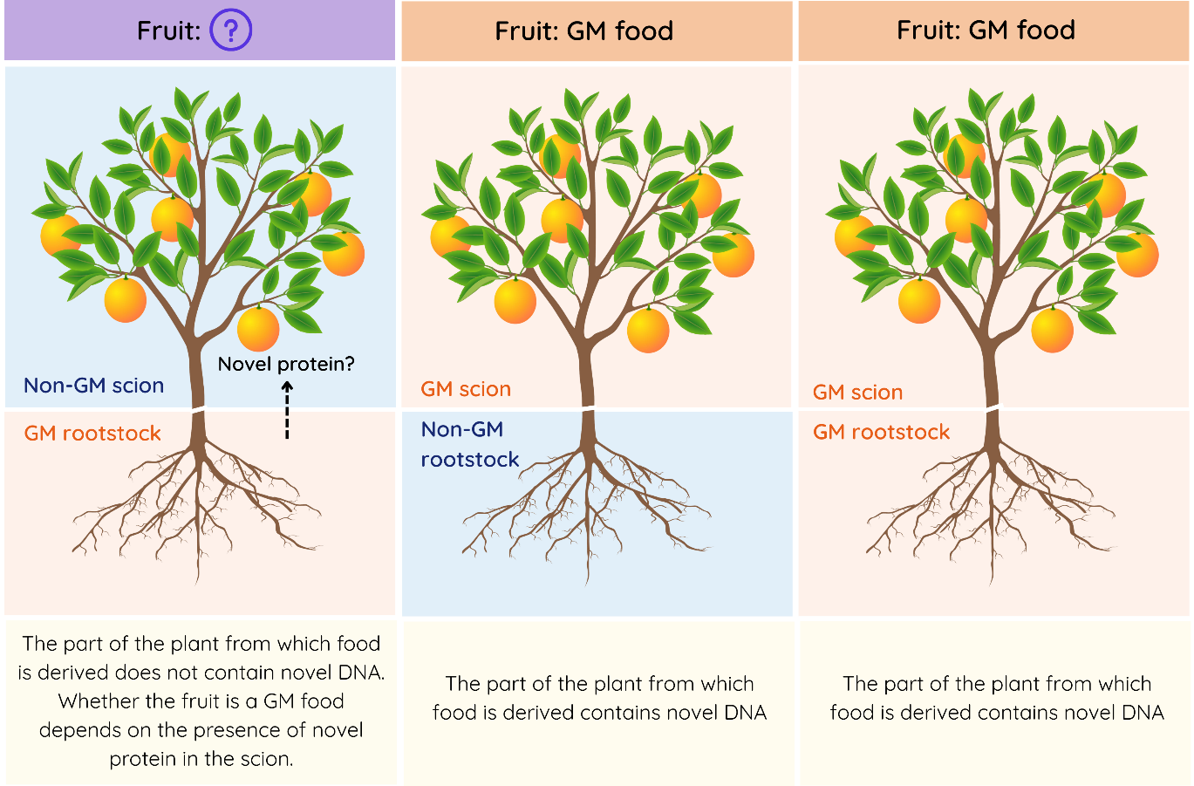
Figure 1 Possible combinations of rootstock/scion in a grafted citrus plant. In this example, the food (fruit) is derived from the scion. Where the scion contains novel DNA, the fruit will be a GM food, irrespective of whether novel protein is also present. If only the rootstock contains novel DNA, the fruit will not contain novel DNA, as the novel DNA is unable to cross the graft junction into the scion. The fruit will therefore not be a GM food provided there has been no transfer of novel protein across the graft junction into the scion.
Grafted plant – example
The scion of a conventional citrus variety is grafted onto a citrus rootstock from a plant whose genome was modified to express a cold-tolerance protein encoded by novel DNA from Arabidopsis thaliana. This trait enhances the rootstock’s resilience to frost and low-temperature stress, enabling citrus production in cool climates.
The citrus fruit, which is the only human food derived from the grafted plant, is from the scion. Because novel DNA cannot move from the rootstock to the scion, and the scion of the plant has been shown not to contain novel protein, the fruit is not a GM food under the Code.


For GM rootstock/non-GM scion combinations where product developers determine an exclusion applies to their food, records or other information supporting this should be retained. This information may be requested by food regulatory agencies to verify compliance with the Code.
The ability of novel proteins to cross the graft junction may depend on their properties, such as size. Where movement across the graft junction cannot be ruled out by scientific rationale alone, analytical evidence may be required.

Food derived from null segregants
Section 1.1.2−16 (2) of the Code defines what is a null segregant for this purpose. See Box 1.
Null segregant – example
Introducing a natural disease-resistance gene into a fruit tree such as a plum using conventional breeding can be a slow process because of the time it takes for trees to flower. To accelerate the breeding process, an early flowering gene from a non-crossable species such as daffodil can be inserted into the plum line to shorten flowering time. The early flowering plum can then be crossed with a disease resistant plum variety to introduce the new disease resistant gene. Due to segregation, not all offspring from the crossing process will inherit the novel DNA (daffodil gene). Offspring that have not inherited the daffodil gene are null segregants as they do not themselves contain novel DNA. Plums derived from plum lines that are null segregants for the daffodil gene are not GM food under the Code.
Product developers who determine the organism, cell or cells to be used for food production is a null segregant should retain records that demonstrate the absence of novel DNA. Such information may be requested by food regulatory agencies to verify compliance with the Code.
To exclude the possibility of novel DNA fragments remaining, results of DNA analyses are recommended in preference to trait expression analyses.

Novel DNA
Section 1.1.2—17 of the Code sets out what is novel DNA (see Box 2)
Box 2.
1.1.2−17 Definition of novel DNA
(1) In this Code, novel DNA means DNA that:
(a) a person has inserted into the genome of an organism, cell or cells; and
(b) is one of the following:
(i) DNA from a species that is not a crossable species;
(ii) DNA that:
(A) is from a crossable species; and
(B) contains a coding region that was rearranged or recombined prior to the insertion referred to in paragraph (1)(a);
(iii) DNA that is not from an existing species.
(2) In this section, crossable species means a species of organism, cell or cells that can be crossed or hybridized with the species of organism, cell or cells referred to in paragraph (1)(a).
(3) Despite subsections (1) and (2), novel DNA does not include flanking left and right border sequences arising from Agrobacterium-mediated transformation.

Determining what is novel DNA
Novel DNA is DNA that meets each of the criteria set out in subsection 1.1.2−17(1).
In determining whether DNA meets the definition of novel DNA, there are two key considerations:
- whether a person has inserted the DNA into the genome of the organism, cell or cells (see section 3.1.1); and
- the source and form of the inserted DNA (see section 3.1.2).
The following decision tree and sections provide step-by-step guidance on the novel DNA definition.

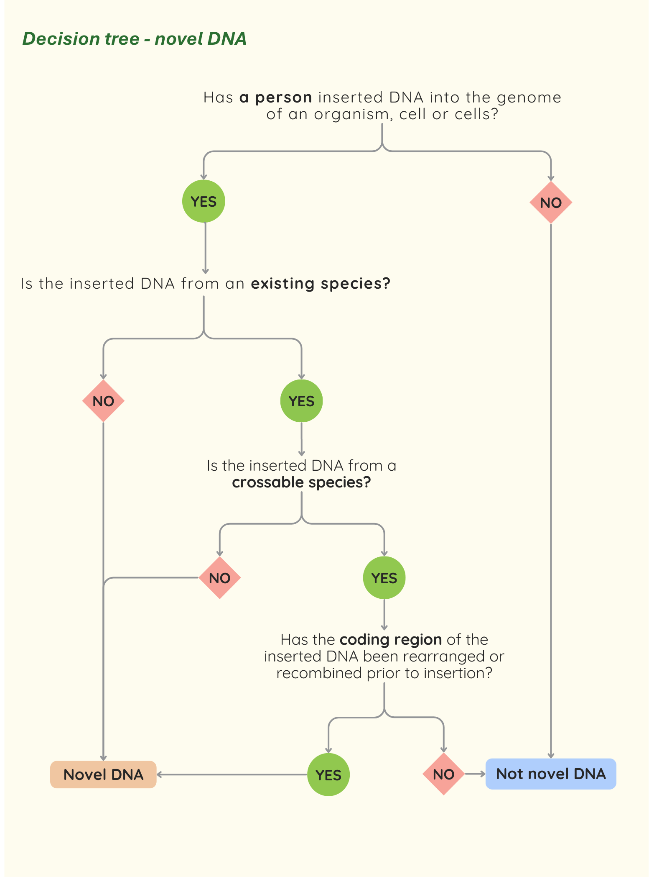

Has a person inserted DNA into the genome of an organism, cell or cells?
For DNA to be novel it must have been inserted into the genome by a person. It does not matter whether insertion of the DNA by a person was intentional or unintentional, both scenarios come within the meaning of a person has inserted.
The insertion of novel DNA through the use of automated processes also comes within the meaning of a person has inserted, as such processes would have been initiated or under the control or direction of a person (see example below).
Automated DNA design and insertion
Advances in artificial intelligence, robotics and automation are increasingly streamlining the process of designing and inserting novel DNA into the genome of various organisms and cells. For example, automated workflows have been developed for cloning synthetic DNA into bacterial hosts, where the entire process, from in silico design to transformation, is accomplished using robotic liquid handling tools (Rosch et al. 2024). Such processes remain under the control and initial direction of a person, hence any resulting novel DNA is considered to have been inserted by a person for the purposes of the Code, regardless of the level of automation involved.

What is the source and form of the inserted DNA?
DNA inserted by a person into the genome of an organism, cell or cells will be novel DNA for the purposes of the Code if it falls into any one of the categories specified in 1.1.2−17(1)(b). These categories are further discussed below.

DNA that is not from an existing species
This refers to DNA sequences that cannot be attributed to an existing species, including DNA that has been computationally designed de novo.
Computational methods are being used to design proteins with structures and functions not found in nature (see example below).
De novo designed DNA – example
To prevent bovine spongiform encephalopathy (BSE) in cattle, a de novo designed gene was inserted into a fertilised cattle embryo. The gene encodes a protein designed to bind to either misfolded or normal prion proteins to block disease progression. The inserted gene, which is not found in any existing species, meets the definition for novel DNA.
Inserted DNA sequences that are designed de novo, and cannot be attributed to any existing species, meet the definition of novel DNA. Foods derived from organisms containing such DNA are GM foods and require an application to FSANZ.
Inserted DNA is considered to be from an existing species if it has either:
- been directly derived from an existing species, for example by being isolated and cloned directly from the genome of the organism; or
- can be attributed to an existing species, for example if it has been chemically synthesised based on a known DNA sequence from an existing species.
Sequence similarity can be used to demonstrate that the inserted DNA originates from an existing species.

Crossable and non-crossable species

When species are crossable
Crossable species are species that can be crossed or hybridized through natural or assisted means, including traditional cross-breeding within species, or wider crosses between species (interspecific crosses) or genera (intergeneric crosses). These species are either naturally sexually compatible or can be made compatible using methods such as embryo rescue, somatic hybridisation, or in vitro fertilisation.
Such crosses or hybridisations, whether they occur through natural or assisted means all come within the meaning of ‘crossable species’. Refer to Table 2 for some examples of species that would be considered crossable.
Product developers should retain records confirming the source species of any inserted DNA (see footnote ¹¹) and that the source species is a crossable species. This information may be requested by food regulatory agencies to support verification of compliance.
Table 2. Examples of crossable species
Example | Organisms | Type | Method Used | Outcome / Purpose | Evidence / References
Triticale | Wheat (genus Triticum) × rye (genus Secale) | Intergeneric cross (plants) | Embryo rescue, polyploidy induction | Cereal crop combining wheat yield and rye stress tolerance | Mergoum & Macpherson  2004
New Rice for Africa (NERICA) | Oryza glaberrima × O. sativa | Interspecific cross (plants) | Embryo rescue | Rice with increased yield and stress resistance | Jones et al. 1997; Zhou et al. 2022
Droughtmaster cattle | Bos taurus × Bos indicus | Interspecific cross (animals) | Selective breeding/artificial selection | Fertile hybrid cattle with heat, drought and tick tolerance | Hayes et al. 2023
Tiger trout | Salmo trutta × Salvelinus fontinalis | Intergeneric cross (animals) | Controlled hatchery breeding, triploid induction | Sterile hybrid for ecological management and stocking | Scheerer et al. 1987
Yeast hybrids | Saccharomyces spp., e.g. Saccharomyces cerevisiae × S. uvarum | Interspecific cross (fungi) | Rare-mating | Fermentation of wines with reduced ethanol content and enhanced aroma | Pérez et al. 2022

When species are not crossable
In many cases it will be self-evident when species are not crossable.
For example, fungi and plants are phylogenetically distinct, meaning their genomes are not compatible and will not hybridise regardless of any assistance using conventional breeding techniques. Fungal DNA inserted into a plant genome by a person would therefore be considered novel DNA. Food derived from such a plant is therefore a GM food for Code purposes and requires pre-market approval before it may be sold.
DNA from a non-crossable species inserted in any configuration, either intentionally or unintentionally, will be considered novel DNA (Figure 2). This includes an entire gene, part of a gene, a non-coding DNA sequence, or DNA from a non-crossable species that is combined with DNA from a crossable species.
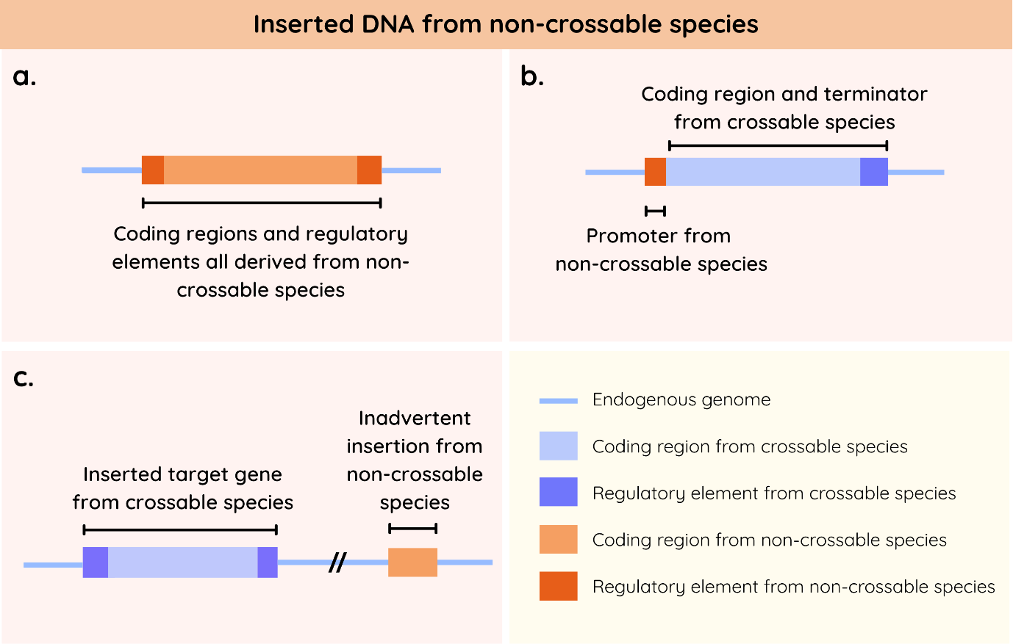
Figure 2 a. an entire gene construct from a non-crossable species has been inserted by a person into the genome of an organism, cell or cells (the ‘endogenous genome’). b. only part of the gene construct that was inserted by a person into the genome of an organism, cell or cells is from a non-crossable species. c. DNA from a non-crossable species has been unintentionally inserted by a person at a site in the genome separate from the target insertion site. All three examples come within the meaning of novel DNA.

Rearranging or recombining the coding region of DNA from a crossable species prior to insertion

Insertion of an intact coding region from a crossable species
If the entire coding region remains in its native configuration prior to insertion, such DNA is not novel DNA. Figure 3 provides illustrative examples.
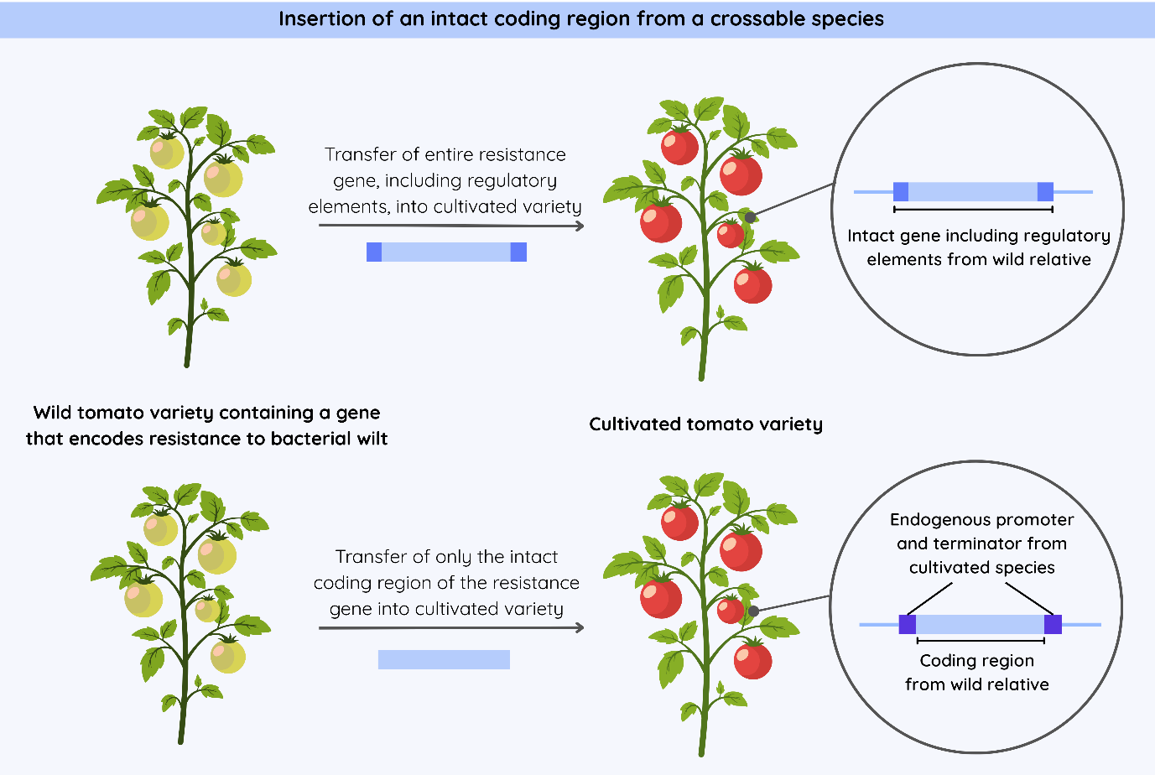Figure 3 The insertion of DNA from a wild tomato variety into a cultivated tomato variety. The wild and cultivated tomato species are sexually compatible and crossable species. The coding region of the inserted DNA has not been rearranged or recombined in both examples. As long as the coding region has not been rearranged or recombined prior to insertion, and all inserted DNA sequences come from crossable species, the introduced DNA is not novel DNA.
The location of the inserted DNA within the genome is not relevant to the meaning of ‘novel DNA’ provided by the Code. In the examples in Figure 3 the inserted DNA may be a direct allelic replacement for an existing gene in its native genomic location or it may be a gene that is inserted randomly into the genome. In both cases the inserted DNA will not be novel DNA.

Insertion of a coding region that was rearranged or recombined
DNA inserted into the genome of a crossable species by a person will be novel DNA if it contains a coding region that has been rearranged or recombined prior to insertion.
Such rearrangement or recombination could involve a full coding region, part of a coding region or parts of multiple coding regions.
For example:
- DNA created by exon shuffling, where exons (protein-coding segments) from different genes or gene variants are recombined to form a new coding sequence (Figure 4a).
- gene constructs for the purpose of RNA interference (RNAi) are typically designed by duplicating and inverting part of the coding region of a gene (Figure 4b). This facilitates the formation of hairpin structures after transcription which activates the cell’s endogenous RNAi pathway. Because this involves the rearrangement of a coding region from the same species (i.e. a crossable species), the inserted DNA is novel DNA.
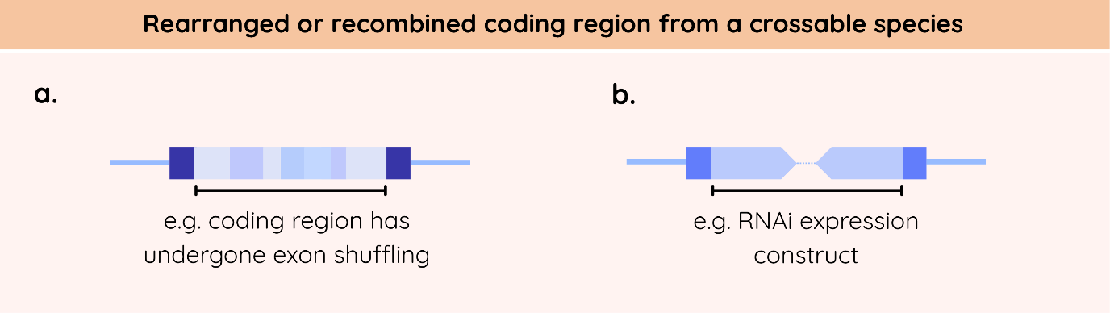Figure 4 Illustration of a. exon shuffling and b. a duplication and inversion of gene segments in an RNAi expression construct. Note, all sequences in this illustration are from crossable species (blue).
Product developers should retain records detailing construct design, including the source of the DNA to be inserted and any modifications to the coding region. This information may be requested by food regulatory agencies to verify compliance with the Code.

What is not novel DNA

Left and right border sequences from Agrobacterium
The novel DNA definition excludes a certain type of non-coding DNA from a bacterial species: flanking left and right border sequences arising from Agrobacterium-mediated transformation. These sequences are short DNA regions that serve as signals to enable Agrobacterium to successfully transfer DNA into a plant genome (Gelvin 2003).
While these sequences would otherwise meet the definition for novel DNA because they are inserted by a person and are from a non-crossable species, they were explicitly excluded from the definition of novel DNA as they are a by-product of the Agrobacterium-mediated insertion process and do not pose any safety concerns (Jacobsen & Schaart 2009).

Endogenous genome changes (natural or induced)
The novel DNA definition was designed to exclude the types of genome changes that occur within the endogenous genome, irrespective of whether they occur naturally/spontaneously or are induced using conventional methods or new breeding techniques.
Endogenous genome changes include point mutations, indels (small nucleotide insertions and/or deletions), chromosomal rearrangements (e.g. inversions, translocations or deletions), whole genome duplication, transposon activation and associated genome changes, and epigenetic changes.
These types of genome changes can occur naturally or may be induced using long standing conventional methods (e.g. classical mutagenesis) or new breeding techniques (e.g. genome editing). Further details can be found in the safety assessment undertaken for P1055.

Short sequences that are attributable to all species
It may not be possible for some inserted DNA sequences to be attributed to a specific species as they can be found in all species, including crossable species.
This may arise for example where restriction site sequences (typically 4-8 nucleotides) used to facilitate the assembly of a DNA construct may be part of the DNA that is inserted into an organism or cells. These sequences are too small to be definitively attributed to any species (crossable or non-crossable) and would also be expected to occur naturally within the host genome. As such, they do not come within the meaning of novel DNA.

Natural insertions
The purpose of stipulating ‘a person has inserted’ in the novel DNA definition is to ensure that food derived from organisms or cells containing novel DNA inserted by natural means do not come within the meaning of GM food as defined by the Code. This includes DNA that has been acquired through natural horizontal gene transfer or trans-kingdom conjugation, e.g. DNA from soil bacteria such as Agrobacterium spp. to plant species. Such natural insertions have been found in the genome of wild and cultivated food crops, like cultivated sweet potato varieties (Kyndt et al 2015).

Codon optimisation
Codon optimisation is a strategy used to modify the DNA sequence of a coding region to incorporate codons that enhance translation efficiency and maximise protein expression in a specific host organism. This is achieved through synonymous nucleotide substitutions, i.e. nucleotide substitutions that do not change the amino acid sequence of the encoded protein. Such synonymous nucleotide variation can arise endogenously within a species.
In terms of the form of the inserted DNA, codon optimisation does not alter the linear structure, boundaries or overall organisation of the coding region itself. As such, inserted DNA from a crossable species where the coding region has been codon optimised is not novel DNA, as these changes do not come within the ordinary meaning of the rearranged or recombined terms used in the novel DNA definition.

Deletions
The deletion of DNA from an organism or cell’s genome does not come within the meaning of novel DNA, i.e. no DNA was ‘inserted’. Such deletions may occur naturally/spontaneously, or from using techniques such as classical mutagenesis or genome editing.

Additional information

Is my food a novel food?
Food that is not a GM food for Code purposes may be subject to regulation as a novel food.
As with GM foods, novel foods require assessment by FSANZ before they may be used and/or sold for retail sale in Australia and New Zealand.
The FSANZ website contains information and resources to assist food businesses to determine if a particular food they wish to bring to market requires pre-market assessment as a novel food. Food businesses may also submit an enquiry to the Advisory Committee on Novel Foods (ACNF), although there is no legal obligation to do so.
A guidance tool has been developed to assist the ACNF in reaching its view. Examples of completed guidance tools are available from the FSANZ website. Once the ACNF has considered the enquiry, it may provide a view about whether the food is a novel food for the purposes of the Code. FSANZ maintains a Record of Views from the ACNF on its website. The Record of Views is provided to help a food business make their own decision about whether they should submit an application to FSANZ for novel food approval.

Changing the Code
The FSANZ website provides essential information required to make an application to vary the Code. Further information can be found on the FSANZ website.

Cultivating or importing GM organisms
In addition to any GM food assessment and approval by FSANZ, activities involving GM organisms are subject to regulation under other Australian or New Zealand regulatory frameworks.
The development, cultivation and environmental release of GM organisms would require separate regulatory assessment and approval by the Gene Technology Regulator in Australia and by the Environmental Protection Agency (EPA) in New Zealand.
The importation of viable GM seeds into either country is subject to separate biosecurity and quarantine requirements. These are managed by the Department of Agriculture, Fisheries and Forestry (DAFF) in Australia and the Ministry for Primary Industries (MPI) in New Zealand.

References
Gelvin SB (2003) Agrobacterium-mediated plant transformation: the biology behind the "gene-jockeying" tool. Microbiol Mol Biol Rev 67(1):16-37. doi: 10.1128/MMBR.67.1.16-37.2003
Hayes BJ, Copley J, Dodd, E, Ross EM, Speight S, Fordyce G (2023) Multi-breed genomic evaluation for tropical beef cattle when no pedigree information is available. Genet Sel Evol 55, 71. doi:10.1186/s12711-023-00847-6
Jacobsen E, Schaart JG (2009) Risk assessment of T-DNA borders from Agrobacterium tumefaciens in cisgenic crops. Wageningen University and Research Centre https://edepot.wur.nl/412300
Jones MP, Dingkuhn M, Aluko GK, Semon M (1997) Interspecific O. sativa L. x O. glaberrima Seeud: Progenies in upland rice improvement. Euphytica 92: 237-246. doi: 10.1023/A:1002969932224
Kyndt T, Quispe D, Zhai H, Jarret R, Ghislain M, Liu Q, Gheysen G, Kreuze JF (2015) The genome of cultivated sweet potato contains Agrobacterium T-DNAs with expressed genes: An example of a naturally transgenic food crop. PNAS 112 (18) 5844-5849. doi: 10.1073/pnas.1419685112
Melnyk CW, Meyerowitz EM (2015) Plant grafting. Curr Biol 25(5):R183-R188. doi:10.1016/j.cub.2015.01.029
Mergoum M, Macpherson HG (2004) Triticale improvement and production (No. 179). Food & Agriculture Organisation https://www.fao.org/4/y5553e/y5553e00.pdf
Pérez D, Denat M, Pérez-Través L, Heras JM, Guillamón JM, Ferreira V, Querol A (2022) Generation of intra- and interspecific Saccharomyces hybrids with improved oenological and aromatic properties. Microb Biotechnol 15(8):2266-2280. doi: 10.1111/1751-7915.14068
Rosch et al. (2024) AutoBioTech – A versatile biofoundry for automated strain engineering. ACS Synth Biol 13(7):2227-2237. doi: 10.1021/acssynbio.4c00298
Scheerer P D, Thorgaard G H, Seeb J E (1987). Performance and developmental stability of triploid Tiger Trout (Brown Trout ♀ X Brook Trout ♂). Trans Am Fish Soc 116(1): 92–97. doi: 10.1577/1548-8659
Zhou J, Yang Y, Lv Y, Pu Q, Li J, Zhang Y, Deng X, Wang M, Wang J, Tao D (2022) Interspecific hybridization is an important driving force for origin and diversification of Asian cultivated rice Oryza sativa L. Front Plant Sci 13:932737. doi: 10.3389/fpls.2022.932737

This is the responsibility of Food Standards Australia New Zealand.
Please refer to the FSANZ webpage on GM food labelling for further information – https://www.foodstandards.gov.au/consumer/gmfood/labelling
Links to further information for these product categories are provided throughout the guidance.
Food regulatory agencies – https://www.foodstandards.gov.au/contact/food-regulatory-agencies
GM food labelling – https://www.foodstandards.gov.au/consumer/gmfood/labelling
Changing the Code – https://www.foodstandards.gov.au/food-standards-code/changing-the-code
Cell-cultured foods – https://www.foodstandards.gov.au/consumer/our-safe-food-supply/Cell-cultured-foods
Novel protein means a protein encoded by novel DNA. The meaning of novel DNA is explained in Section 3.
Sometimes called ‘three-segment’ or ‘interstock’ grafting.
For example, the unintentional integration of bacterial plasmid DNA into the genome of cattle during genome editing.
For example, using the National Center for Biotechnology Information (NCBI) Basic Local Alignment Search Tool (BLAST) – https://blast.ncbi.nlm.nih.gov/Blast.cgi
This may take the form of a simple rationale (e.g. cows and bulls of the same species cross naturally), a scientific argument using supporting literature that such crosses or hybridisations are technically possible, or by referring to examples where such a cross or hybridisation has occurred previously.
It meets paragraph 1.1.2—17(1)(a), having been inserted by a person, as well as paragraph 1.1.2—17(1)(b)(i): i.e. not from a crossable species.
This applies to both coding regions and regulatory elements from non-crossable species.
It meets paragraph 1.1.2—17(1)(a), having been inserted by a person, as well as paragraph 1.1.2—17(1)(b)(ii): i.e. it is from a crossable species and was rearranged or recombined prior to insertion.
Note – this applies to RNAi constructs targeting endogenous gene expression, where the part of the coding region being used originates from the same (i.e. a crossable) species. RNAi constructs can also be designed to target exogenous sequences (for example from a pest or pathogen). In such cases the inserted DNA would be novel DNA because it is derived from a non-crossable species.
Small insertions in the genome (a single or few bases) can be induced using genome editing. These insertions arise endogenously when new DNA is synthesised during the repair of a double stranded break. Hence, the introduced base(s) are attributable to the host species (i.e. a crossable species) and would not be novel DNA.
The mobilisation of genetic elements from one location to another within a genome.
P1055 Safety assessment – safety assessment: full technical report
Novel foods – https://www.foodstandards.gov.au/business/novel
ACNF – https://www.foodstandards.gov.au/business/novel/novelcommittee
The ACNF recommendations are not legal advice and are not legally binding, nor do they represent advice, recommendations, or decisions by FSANZ on whether a food is or is not a novel food.
Changing the Code – https://www.foodstandards.gov.au/food-standards-code/changing-the-code
The Office of the Genet Technology Regulatory (OGTR) provides administrative support to the Gene Technology Regulator in the performance of functions under the Gene Technology Act 2000. Further information can be found on the OGTR website – https://www.ogtr.gov.au/
The EPA implements and enforces the Hazardous Substances and New Organisms (HSNO) Act 1996. Further information can be found on the EPA website – https://www.epa.govt.nz/industry-areas/new-organisms/
Further information can be found on the DAFF website – https://www.agriculture.gov.au/. Information on importing GM organisms and products containing GM organisms can be found on the OGTR website – https://www.ogtr.gov.au/about-approval-process/import-transport-storage-and-disposal
Further information can be found on the MPI website – https://www.mpi.govt.nz/. Information on GM seeds and nursery stock can be found via the following link – https://www.mpi.govt.nz/import/plants-flowers-seeds-plant-growing-products/seeds-for-sowing/genetically-modified-seeds-and-nursery-stock

