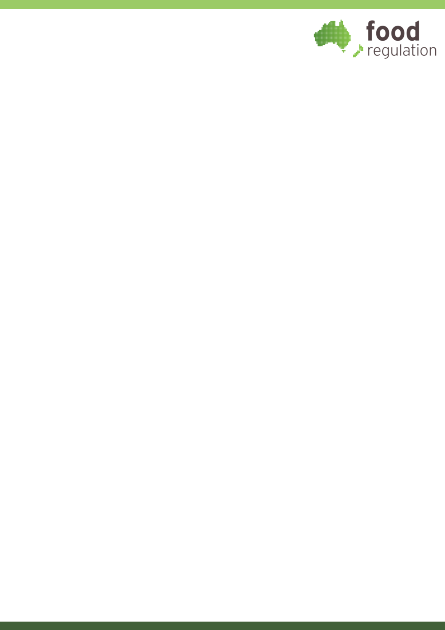
Energy labelling on alcoholic beverages Guidance for producers, importers, suppliers, distributors and retailers

Energy labelling on alcoholic beverages

Introduction
The Australia New Zealand Food Standards Code (the Code) was updated in August 2025 to make it mandatory for most packaged alcoholic beverages to declare energy content information. This document provides information on how these new requirements apply to foods for retail sale, and how to comply with them.
On the following pages you will find information about:
which beverages must include energy information
how to display energy information on packaging
an online tool that can assist in the calculation of an average energy content and produce an energy statement for use on product labels
when the new requirements will take effect.

Beverages that must declare the energy content on their label
Energy content information must be declared on:
standardised alcoholic beverages
other beverages containing no less than 0.5% alcohol by volume (ABV).
Standardised alcoholic beverages are beer, brandy, cider, fruit wine, fruit wine product, liqueur, mead, perry, spirit, vegetable wine, vegetable wine product, wine or wine product. This includes versions of these beverages that have less than 0.5% ABV.
Beverages containing no less than 0.5% ABV include ready to drink alcoholic beverages such as seltzers and premixed spirits as well as brewed soft drinks.
Some alcoholic beverages are exempt from displaying energy content information. This applies to beverages that:
already display a nutrition information panel (NIP)
come in a small package with a surface area of less than 100 cm²
do not have to bear a label (if a food for retail sale).

The energy statement - a standardised format for energy labelling
Standardised alcoholic beverages and beverages containing no less than 0.5% alcohol by volume (ABV) that must display energy content information must use the prescribed format called an energy statement.
Prescribed format for an energy statement:
ENERGY INFORMATION
Servings per package: (insert number of servings)
Serving size: mL ([insert number] standard drinks)
 | Quantity per serving | Quantity per 100 mL
Energy | kJ (Cal) | kJ (Cal)

The energy statement must include the average energy content of the alcoholic beverage in kilojoules (kJ) or in both kJ and kilocalories (Cal), per serving, and per 100 mL. The average energy content values must not have more than three significant figures.
It must be clearly indicated that any average quantities set out in the statement are average quantities. For example, this could be indicated in the column headings (as shown in the image below) as ‘Average quantity per serving’ and ‘Average quantity per 100 mL’.
Example indicating averages in column headings:
ENERGY INFORMATION
Servings per package: 12
Serving size: 60 mL (1 standard drink)
 | Average quantity per serving | Average quantity per 100 mL
Energy | 355 kJ | 592 kJ

As well as average energy content, the energy statement must include:
the number of servings in the package (see Note 1 below),
the average quantity in one serving in millilitres (mL)
the approximate number of standard drinks equivalent to one serving, accurate to one decimal place (see Note 2 below).
Note 1: In an energy statement, ‘package’ may be replaced by ‘can’, ‘bottle’ or any other word(s) that accurately describes the package.
Note 2: The total number of standard drinks in the package must still be displayed elsewhere on the label. The requirement to include standard drinks per serving in the energy statement does not replace this – both pieces of information must appear on the label.
The energy statement can include additional information showing the energy content as a percentage of daily intake (%DI). This information is optional.
If %DI is included, it must be calculated using a reference value of 8700 kJ and be displayed in the energy statement using the format below.
Format of energy statement with %DI information:
ENERGY INFORMATION
Servings per package: (insert number of servings)
Serving size: mL ([insert number] standard drinks)
 | Quantity per serving | % Daily intake* (per serving) | Quantity per 100 mL
Energy | kJ (Cal) | % | kJ (Cal)
*Percentage daily intakes are based on an average adult diet of 8700 kJ.
This energy statement must also include one of the following statements (the format above uses the second statement):
Based on an average diet of 8700 kJ, or
Percentage daily intakes are based on an average adult diet of 8700 kJ.

Calculating average energy content
The existing rules in the Code for determining average energy content (Schedule 11) will also apply to energy labelling on alcoholic beverages. This requires the use of a specific equation (provided in Schedule 11) that relies on ‘average’ quantities of certain components. The quantities of these components may be determined using generally accepted data or laboratory analysis.
An online calculator tool has also been developed to assist businesses in creating an energy statement for their products (see below).

Online average energy calculator
FSANZ has developed an online calculator to assist businesses to:
work out the average energy content for packaged alcoholic beverages, and
prepare an energy statement.
Use of the calculator is not mandatory. For more information, please visit the FSANZ website.

How to manage variations in an alcoholic beverage’s energy content
There are no specific tolerance levels in the Code for average energy content. Instead, the equation in the Code for average energy content uses ‘average’ quantities of components and applies tolerance levels for ABV for different products. As a result, the average energy content shown on the label is permitted to differ slightly from the actual energy content of a particular batch of an alcoholic beverage. This approach allows businesses to use an average value across different batches of the same product (e.g. different batches of beer).

Energy statements on multilayered packages
The energy statement is required on only one layer of packaging – usually the outermost layer – so it is visible and legible at point of purchase. It is not required on transportation outers (containers or wrappers used for food transport and distribution) that are removed before sale.
The energy statement can be included voluntarily on other layers of packaging of a product and, if provided, will not be considered a nutrition content claim. This gives producers flexibility in how to package and sell their products, while ensuring labelling remains compliant.
The Code does not require an energy statement to be placed on individual products that are part of a multipack (e.g. a carton of cans) if these individual products are not designed for individual sale. In this situation the energy statement can be placed on the outer packaging of the multipack. The energy statement may either refer to the number of servings in the entire multipack, or in each individual unit in the multipack, as long as it clearly identifies the package being described.
If there are different individual products in a multipack (e.g. a ‘mixed pack’), then the outer package will need to display energy statements for each individual product if they are not visible and legible at the point of purchase.

Alcoholic beverages with a nutrition information panel
Standardised alcoholic beverages and beverages containing no less than 0.5% alcohol by volume (ABV) must include a NIP on their label if a nutrition content or health claim is made.
Most other alcoholic beverages do not need to include a NIP on their label. However, the Code allows for a NIP to be provided voluntarily. If a NIP is displayed on an alcoholic beverage, then it must follow the prescribed format and content requirements that apply to all other foods, with one exception related to the number of serves as described below.
Format of nutrition information panel:
NUTRITION INFORMATION
Servings per package: ([insert number] servings)
Serving size: mL ([insert number] standard drinks)
 | Quantity per serving | Quantity per 100 mL
Energy | kJ (Cal) | kJ (Cal)
Protein | g | g
Fat, total | g | g
-saturated | g | g
Carbohydrates | g | g
-sugars | g | g
Sodium | mg | mg
NIPs on alcoholic beverages may also need to include additional information relating to the number of standard drinks in a serving:
If the product for sale contains more than one serving, the NIP must include the approximate number of standard drinks equivalent to one serving of the beverage.
If the product for sale contains only one serving, the standard drinks information may be stated in the NIP, but it is not a mandatory requirement (see Note 1).
When included in the NIP, the standard drinks information must be listed in the amount per serving immediately below the serving size and in brackets (see above; also Note 2).
Note 1: This provision only applies to NIPs on alcoholic beverages. If an energy statement is used, the number of standard drinks equivalent to one serving must be provided regardless of the number of servings in the beverage.
Note 2: The total number of standard drinks in the package must still be displayed elsewhere on the label. The requirement to include standard drinks per serving in the NIP does not replace this requirement – both pieces of information must appear on the label.

Imported products
All food and beverages imported into Australia and New Zealand must comply with the Code. This means that alcoholic beverages imported into Australia or New Zealand must meet the energy labelling requirements. Stickers may be used to provide the required energy statement or NIP, so long as it is available on the product for retail sale.
Other forms of nutrition information may also be present on the product, as long as the Code requirements are met.

Legibility requirements
The Code requires all words, statements, expressions and designs on a label to be legible, prominent and in English (section 1.2.1—24). These requirements also apply to energy statements and NIPs on alcoholic beverages.
The Code does not impose additional legibility restrictions for energy statements or NIPs on alcoholic beverages.

Implementation timeframe
There is a 3-year transition period from 13 August 2025 for implementation of the new labelling requirements. During this transition period, a product can be sold if it meets either the previous requirements in the Code, or the new energy information requirements.
Products packaged and labelled before the end of the transition period can continue to be sold after this date provided they complied with the previous requirements in the Code.

Health claims are not permitted on foods that contain more than 1.15% ABV, and only certain nutrition content claims are permitted on foods that contain more than 1.15% ABV. See section 1.2.7—4 of the Code.

